**Network Media**

Media is the actual physical environment through which data travels as it moves from one component to another, and it connects network devices. The most common types of network media are twisted-pair cable, coaxial cable, fiber-optic cable, and wireless. Each media type has specific capabilities and serves specific purposes.

Understanding the types of connections that can be used within a network provides a better understanding of how networks function in transmitting data from one point to another.

**Coaxial Cable**

*Coaxial cable* consists of a hollow outer cylindrical conductor that surrounds a single inner wire conducting element. This section describes the characteristics and uses of coaxial cable.

As shown in Figure bellow, the single inner wire located in the center of a coaxial cable is a copper conductor, surrounded by a layer of flexible insulation. Over this insulating material is a woven copper braid or metallic foil that acts both as the second wire in the circuit and as a shield for the inner conductor. This second layer, or shield, can help reduce the amount of outside interference. An outer jacket covers this shield. The BNC connector shown looks much like a cable-television connector and connects to an older NIC with a BNC interface.

**Coaxial Cable**

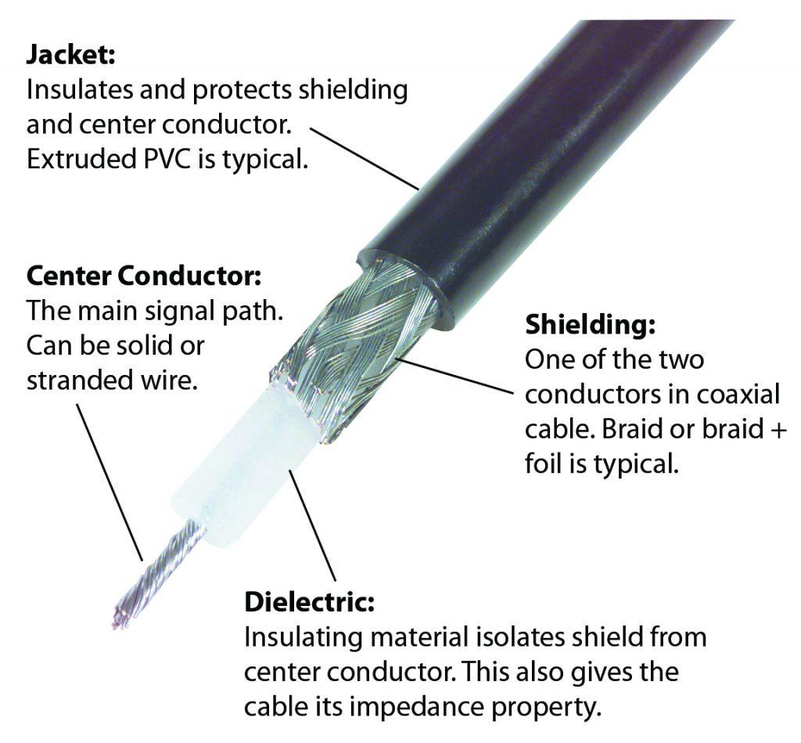

Coaxial cable supports 10 to 100 Mbps and is relatively inexpensive, although more costly than UTP. Coaxial cable can be laid over longer distances than twisted-pair cable. For example, Ethernet can run approximately 100 meters using twisted-pair cable, but 500 meters using coaxial cable.

Coaxial cable offers several advantages for use in LANs. It can be run with fewer boosts from repeaters, which regenerate the signals in a network so that they can cover greater distances between network nodes than either STP or UTP cable. Coaxial cable is less expensive than fiber-optic cable, and the technology is well known. It has been used for many years for all types of data communication.

When you work with cable, consider its size. As the thickness, or diameter, of the cable increases, so does the difficulty in working with it. Cable must often be pulled through existing conduits and troughs that are limited in size. Coaxial cable comes in a variety of sizes. The largest diameter, frequently referred to as *Thicknet*, was specified for use as Ethernet backbone cable because historically it had greater transmission length and noise rejection characteristics. However, Thicknet cable can be too rigid to install easily in some environments because of its thickness. Generally, the more difficult the network media is to install, the more expensive it is to install. Coaxial cable is more expensive to install than twisted-pair cable, and Thicknet cable is almost never used except for special-purpose installations, where shielding from EMI or distance requires the use of such cables.

In the past, coaxial cable with an outside diameter of only 0.35 cm, sometimes referred to as *Thinnet*, was used in Ethernet networks. It was especially useful for cable installations that required the cable to make many twists and turns. Because Thinnet was easier to install, it was also cheaper to install. Thus, it was also referred to as *Cheapernet*. However, because the outer copper or metallic braid in coaxial cable comprised half the electrical circuit, special care needed to be taken to ground it properly, by ensuring that a solid electrical connection existed at both ends of the cable. Installers frequently failed to make a good connection. Connection problems resulted in electrical noise, which interfered with signal transmission. For this reason, despite its small diameter, Thinnet is no longer commonly used in Ethernet networks.

Although coaxial cable offers some distance advantages over twisted-pair, the disadvantages far outweigh the benefits. If a communications signal needs to travel a greater distance at high rates of speed, it is more common to use fiber-optic cable.

**Fiber-Optic Cable**

*Fiber-optic cable* is a networking medium capable of conducting modulated light transmission. This section describes the types, characteristics, and uses of fiber-optic cable.

Fiber-optic cable used for networking consists of two fibers encased in separate sheaths. Viewing it in cross section in Figure 4-4, you can see that each optical fiber is surrounded by layers of protective buffer material: usually a plastic shield, then a plastic such as Kevlar, and finally, an outer jacket that provides protection for the entire cable. The plastic conforms to appropriate fire and building codes. The purpose of the Kevlar is to furnish additional cushioning and protection for the fragile, hair-thin glass fibers. Where buried fiber-optic cables are required by codes, a stainless steel wire is sometimes included for added strength. Several connectors can connect fiber to the networking device; the most common is a SC connector, which has two optics, one connecting to transmit and the other connecting to receive.

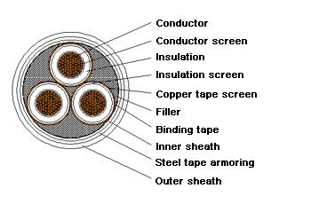

**Fiber-Optic Cable**

The light-guiding parts of an optical fiber are called the *core* and the *cladding*. The core is usually very pure glass with a high index of refraction. When a cladding layer of glass or plastic with a low index of refraction surrounds the core glass, light can be trapped in the fiber core. This process is called *total internal reflection*, and it allows the optical fiber to act like a light pipe, guiding light for long distances, even around bends. Fiber-optic cable is the most expensive of the three types discussed in this lesson, but it supports higher rate line speeds.

Fiber-optic cable does not carry electrical impulses as copper wire does. Instead, signals that represent bits are converted into pulses of light. Two types of fiber-optic cable exist:

* **Single-mode**—Single-mode fiber-optic cable allows only one mode (or wavelength) of light to propagate through the fiber. This type of cable is capable of higher band-width and greater distances than multimode and is often used for campus backbones. Single-mode cable uses lasers as the light-generating method and is more expensive than multimode cable. The maximum cable length of single-mode cable is 60+ km (37+ miles). Most single mode **fiber** Internet providers offer **speeds** up to 10 Gbps.

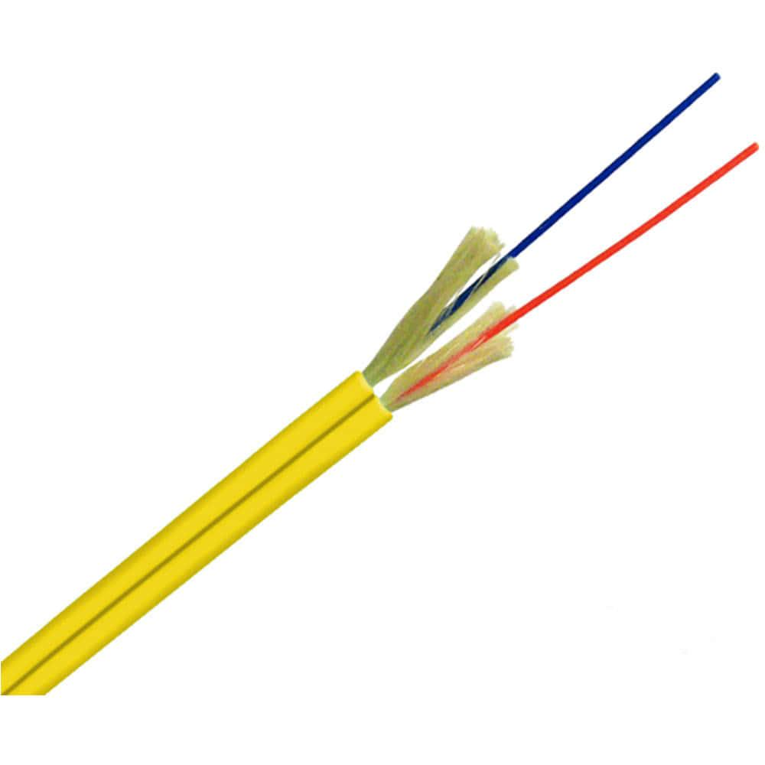

* **Multimode**—Multimode fiber-optic cable allows multiple modes of light to propagate through the fiber. Multimode cable is often used for workgroup applications, using light emitting diodes (LEDs) as light-generating devices. The maximum length of multimode cable is 2 km (1.2 miles) and maximum speed is 500 Mbps.

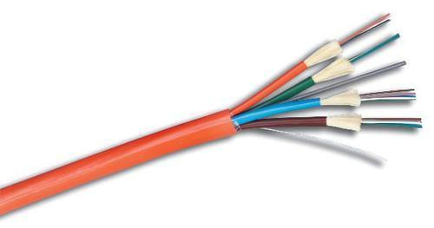

The characteristics of the different media have a significant impact on the speed of data transfer. Although fiber-optic cable is more expensive, it is not susceptible to EMI and is capable of higher data rates than any of the other types of networking media discussed here. Fiber-optic cable is also more secure because it does not emit electrical signals that could be received by external devices.

**NOTE**

Even though light is an electromagnetic wave, light in fibers is not considered wireless because the electromagnetic waves are guided in the optical fiber. The term *wireless* is reserved for radiated, or unguided, electromagnetic waves.

In some instances, it might not be possible to run any type of cable for network communications. This situation might be the case in a rented facility or in a location where you do not have the ability to install the appropriate infrastructure. In these cases, it might be useful to install a wireless network, as discussed in the next section.

**Wireless Communications**

Wireless networks are becoming increasingly popular, and they utilize a different type of technology. Wireless communication uses radio frequencies (RFs) or infrared waves to transmit data between devices on a LAN. For wireless LANs, a key component is the wireless hub, or access point, used for signal distribution. To receive the signals from the access point, a PC or laptop needs to install a wireless adapter card, or wireless network interface card (NIC). Figure 4-5 shows a number of wireless access points connected to an Ethernet backbone to provide access to the Internet.

**Wireless Access Points**

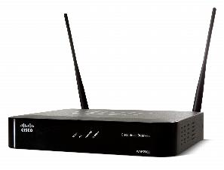

Wireless signals are electromagnetic waves that can travel through the vacuum of outer space and through a medium such as air. No physical medium is necessary for wireless signals, making them a versatile way to build a network. They use portions of the RF spectrum to transmit voice, video, and data. Wireless frequencies range from 3 kHz to 300 GHz. The data-transmission rates range from 9 kbps to 54 Mbps. **Figure 4-6****Electromagnetic Spectrum**

Some common applications of wireless data communication include the following:

* Accessing the Internet using a cellular phone
* Home or business Internet connection over satellite
* Beaming data between two handheld computing devices
* Wireless keyboard and mouse for the PC

Another common application of wireless data communication is the wireless LAN (WLAN), which is built in accordance with Institute of Electrical and Electronic Engineers (IEEE) 802.11 standards. WLANs typically use radio waves (for example, 902 MHz), microwaves (for example, 2.4 GHz), and infrared (IR) waves (for example, 820 nm) for communication. Wireless technologies are a crucial part of the future of networking.

**Twisted-Pair Cable**

*Twisted-pair* is a copper wire-based cable that can be either shielded or unshielded. Twisted- pair is the most common media for network connectivity.

Unshielded twisted-pair (UTP) cable, as shown in Figure 4-1, is a four-pair wire. Each of the eight individual copper wires in UTP cable is covered by an insulating material. In addition, the wires in each pair are twisted around each other. The advantage of UTP cable is its ability to cancel interference, because the twisted-wire pairs limit signal degradation from electromagnetic interference (EMI) and radio frequency interference (RFI). To further reduce crosstalk between the pairs in UTP cable, the number of twists in the wire pairs varies. UTP, as well as shielded twisted-pair (STP) cable, must follow precise specifications as to how many twists or braids are permitted per meter.

**Unshielded Twisted-Pair Cable:**

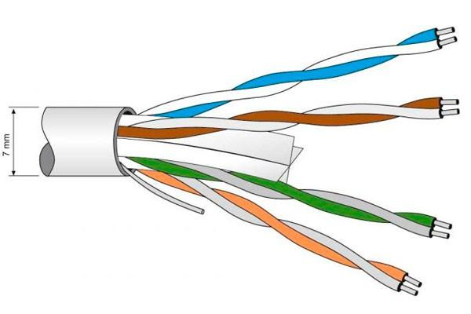

UTP cable is used in a variety of networks. When used as a networking medium, UTP cable has four pairs of either 22- or 24-gauge copper wire. UTP used as a networking medium has an impedance of 100 ohms, differentiating it from other types of twisted-pair wiring such as that used for telephone wiring. Because UTP cable has an external diameter of approximately 0.43 cm (0.17 inches), its small size can be advantageous during installation. Also, because UTP can be used with most of the major networking architectures, it continues to grow in popularity.

Several categories of UTP cable exist:

* **Category 1**—Used for telephone communications; not suitable for transmitting data
* **Category 2**—Capable of transmitting data at speeds of up to 4 Mbps
* **Category 3**—Used in 10BASE-T networks; can transmit data at speeds up to 10 Mbps
* **Category 4**—Used in Token Ring networks; can transmit data at speeds up to 16 Mbps
* **Category 5**—Capable of transmitting data at speeds up to 100 Mbps
* **Category 5e**—Used in networks running at speeds up to 1000 Mbps (1 Gbps)
* **Category 6**—Consists of four pairs of 24-gauge copper wires that can transmit data at speeds up to 1000 Mbps

**Shielded Twisted-Pair Cable**

Shielded twisted-pair (STP) cable, as shown in Figure 4-2, combines the techniques of shielding and the twisting of wires to further protect against signal degradation. Each pair of wires is wrapped in a metallic foil. The four pairs of wires are then wrapped in an overall metallic braid or foil, usually 150-ohm cable. Specified for use in Ethernet network installations, STP reduces electrical noise both within the cable (pair-to-pair coupling, or crosstalk) and from outside the cable (EMI and RFI). Token Ring network topology uses STP.

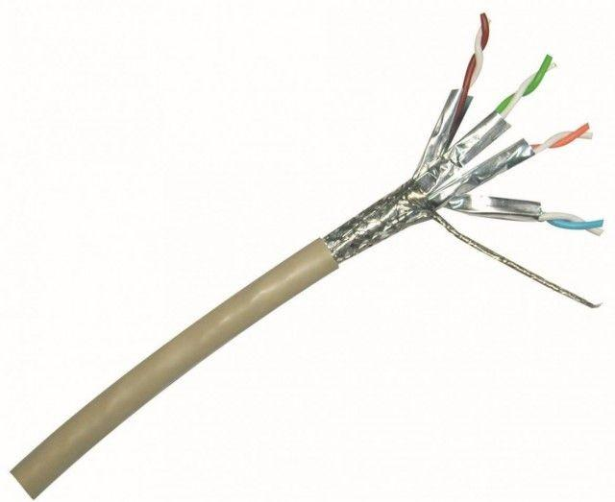

When you consider using UTP and STP for your network media, consider the following:

* Speed of either media type is usually satisfactory for local-area distances.
* Both are the least-expensive media for data communication. UTP is less expensive than STP.
* Because most buildings are already wired with UTP, many transmission standards are adapted to use it to avoid costly rewiring with an alternative cable type.

Twisted-pair cabling is the most common networking cabling in use today; however, some networks still use older technologies like coaxial cable, as discussed in the next section.

# **Difference of Straight Through and Crossover Cable**

Ethernet cables can be wired as straight through or crossover. The straight through is the most common type and is used to connect computers to hubs or switches. They are most likely what you will find when you go to your local computer store and buy a patch cable. Crossover Ethernet cable is more commonly used to connect a computer to a computer and may be a little harder to find since they aren’t used nearly as much as straight through Ethernet cable. Then, what’s the difference between straight through vs crossover cable? Read through this post to find the answer.

**T568A And T568B Wiring Standard Basis**

A RJ45 connector is a modular 8 position, 8 pin connector used for terminating Cat5e patch cable or Cat6 cable. A pinout is a specific arrangement of wires that dictate how the connector is terminated. There are two standards recognized by ANSI, TIA and EIA for wiring Ethernet cables. The first is the T568A wiring standard and the second is T568B. T568B has surpassed 568A and is seen as the default wiring scheme for twisted pair structured cabling. If you are unsure of which to use, choose 568B.

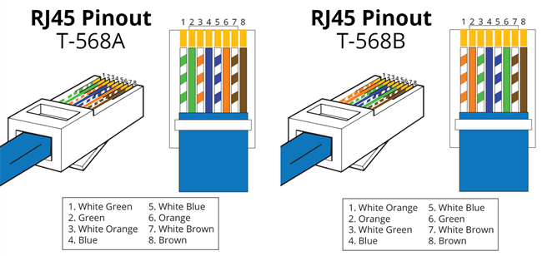

## Straight Through vs Crossover Cable

**What Is Straight Through Cable?**

A straight through cable is a type of twisted pair cable that is used in local area networks to connect a computer to a network hub such as a router. This type of cable is also sometimes called a patch cable and is an alternative to wireless connections where one or more computers access a router through a wireless signal. On a straight through cable, the wired pins match. Straight through cable use one wiring standard: both ends use T568A wiring standard or both ends use T568B wiring standard. The following figure shows a straight through cable of which both ends are wired as the T568B standard.

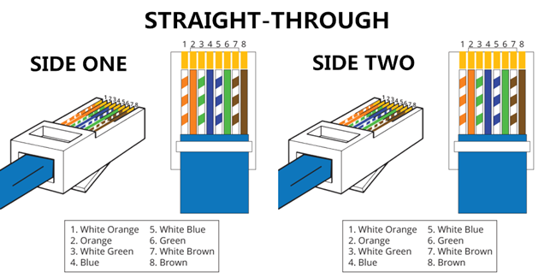

**What Is Crossover Cable?**

A crossover Ethernet cable is a type of Ethernet cable used to connect computing devices together directly. Unlike straight through cable, the RJ45 crossover cable uses two different wiring standards: one end uses the T568A wiring standard, and the other end uses the T568B wiring standard. The internal wiring of Ethernet crossover cables reverses the transmit and receive signals. It is most often used to connect two devices of the same type: e.g. two computers (via network interface controller) or two switches to each other.

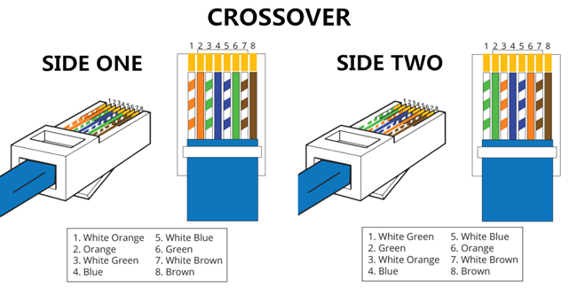

## It doesn’t matter which of these wiring schemes you use, but pick one and stick with it. If you use one wiring standard on one end of a cable and the other standard on the other end, the cable won’t work.

## Pin Connections for Twisted-Pair Cable

|  |  |  |  |
| --- | --- | --- | --- |
| Pin Number | Function | EIA/TIA 568A | EIA/TIA 568B AT&T 258A |
| Pin 1 | Transmit + | White/green | White/orange |
| Pin 2 | Transmit - | Green | Orange |
| Pin 3 | Receive + | White/orange | White/green |
| Pin 4 | Unused | Blue | Blue |
| Pin 5 | Unused | White/blue | White/blue |
| Pin 6 | Receive - | Orange | Green |
| Pin 7 | Unused | White/brown | White/brown |
| Pin 8 | Unused | Brown | Brown |

**Straight Through vs Crossover Cable, which to choose?**

Straight through vs crossover cable, which one should I choose? Usually, straight through cables are primarily used for connecting unlike devices. And crossover cables are use for connecting alike devices.  
Use straight through Ethernet cable for the following cabling:

* Switch to router
* Switch to PC or server
* Hub to PC or server

Use crossover cables for the following cabling:

* Switch to switch
* Switch to hub
* Hub to hub
* Router to router
* Router Ethernet port to PC NIC
* PC to PC

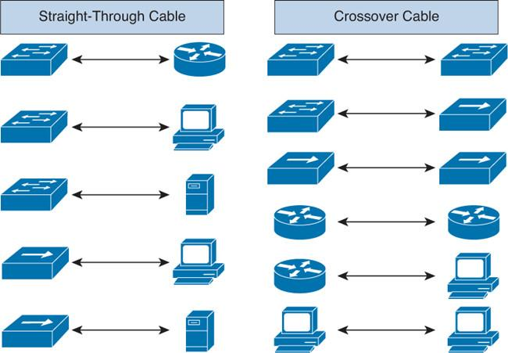

## Conclusion on Straight Through vs Crossover Cable

Straight through and crossover cables are wired differently from each other. One easy way to tell what you have is to look at the order of the colored wires inside the RJ45 connector. If the order of the wires is the same on both ends, then you have a straight through cable. If not, then it’s most likely a crossover cable or was wired wrong. At present, the straight through cable is much more popular than crossover cable and is widely used by people.

**Comparing Media Types**

The choice of media type affects the type of network interface cards installed, the speed of the network, and the ability of the network to meet future needs. Table 4-1 compares the features of the common network media, including UTP, STP, coaxial cable, fiber-optic, and wireless connections.

**Table 8-1 Media Type Comparison**

|  |  |  |  |  |  |
| --- | --- | --- | --- | --- | --- |
| **Media Type** | **Maximum Segment Length** | **Speed** | **Cost** | **Advantages** | **Disadvantages** |
| UTP | 100 m | 10 Mbps to 1000 Mbps | Least expensive | Easy to install; widely available and widely used | Susceptible to interference; can cover only a limited distance |
| STP | 100 m | 10 Mbps to 100 Mbps | More expensive than UTP | Reduced crosstalk; more resistant to EMI than Thinnet or UTP | Difficult to work with; can cover only a limited distance |
| Coaxial | 500 m (Thicknet)  185 m (Thinnet) | 10 Mbps to 100 Mbps | Relatively inexpensive, but more costly than UTP | Less susceptible to EMI interference than other types of copper media | Difficult to work with (Thicknet); limited bandwidth; limited application (Thinnet); damage to cable can bring down entire network |
| Fiber-Optic | 10 km and farther (single-mode)  2 km and farther (multimode) | 100 Mbps to 100 Gbps (single mode)  100 Mbps to 9.92 Gbps (multimode) | Expensive | Cannot be tapped, so security is better; can be used over great distances; is not susceptible to EMI; has a higher data rate than coaxial and twisted-pair cable | Difficult to terminate |

The media you choose has an important impact on the network's capabilities. You should consider all the factors before making your final selection.